CO 2 - ASSESSMENT TOOL -2

Name : Lanka Kavya Subject Code : CSA1003
Registration Number : 192472298 Subject Name : Software Engineering
Hotel Reservation and Room Management Platform with Dynamic Pricing

Analyze System Requirements

System Objectives
- Enable online hotel room reservations.
- Manage room availability in real time.
- Implement dynamic pricing based on demand, occupancy, and season.
- Provide secure online payment.
- Generate booking and revenue reports.
- Improve customer satisfaction and hotel revenue.

Functional Requirements
- User Registration and Login
- Search Available Rooms
- View Room Details
- Book Room
- Cancel Booking
- Online Payment
- Dynamic Pricing
- Room Management
- Booking Management
- Customer Management
- Reports and Analytics
- Notifications

Non-Functional Requirements
- High Performance
- Security
- Reliability
- Scalability
- Availability
- Maintainability
- Usability

Quality Attributes

Scalability

Maintainability

Reliability

Availability

Performance

Security

2. Select Suitable Software Architecture

Selected Architecture
Layered Architecture (Three-Tier Architecture)

Justification
- Separates presentation, business logic, and database layers.
- Easy to maintain.
- Highly scalable.
- Better security.
- Easier testing.
- Supports future enhancements.

3. Software Architecture Diagram
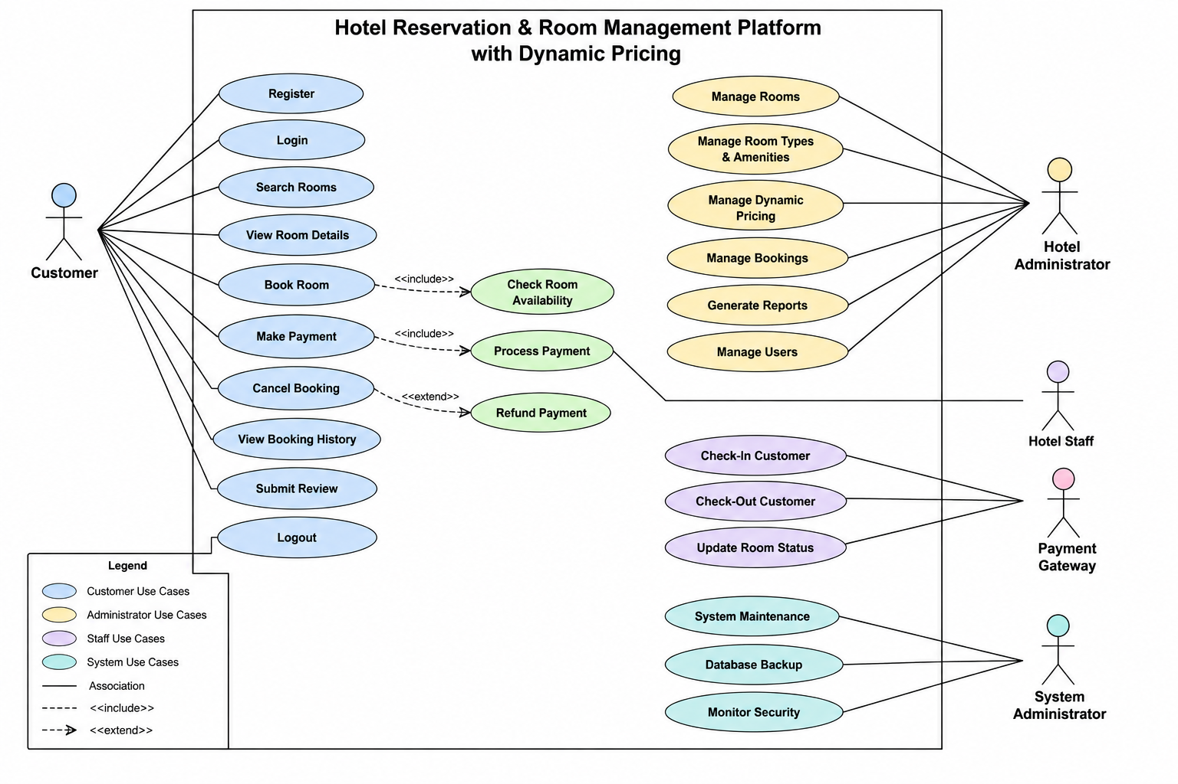

4. Components and Their Interactions

Presentation Layer
Responsibilities:
- User Interface
- Login
- Search Rooms
- Booking
- Payment Screens

Business Logic Layer

Authentication Service

Booking Service

Dynamic Pricing Engine

Payment Service

Notification Service

Report Service

Data Access Layer

Database
Stores:
- Customer Information
- Room Details
- Booking Records
- Payment Records
- Pricing Rules
- Reports

System Workflow
- User logs into the system.
- Searches available rooms.
- Booking service checks room availability.
- Dynamic Pricing Engine calculates the room price.
- User confirms booking.
- Payment Service processes the payment through the Payment Gateway.
- Booking is stored in the database.
- Notification Service sends confirmation via Email/SMS.
- Administrator manages bookings and generates reports.

5. Quality Attribute Discussion

Scalability

Security

Performance

Reliability

Maintainability

Availability

6. Architectural Justification

Reasons for Choosing Layered Architecture
- Clear separation of responsibilities.
- Easier debugging and maintenance.
- Supports future expansion.
- Enhances code reusability.
- Simplifies testing.
- Improves security.

Trade-offs

Advantages
- Easy maintenance
- High scalability
- Better security
- Modular design
- Easy integration

Disadvantages
- Slightly slower due to multiple layers.
- More initial development effort.

Future Enhancements
- AI-based room recommendation.
- Machine learning for demand prediction.
- Mobile application.
- Multi-language support.

